This model form/template must be customized to meet your Agency’s needs.

When to Report
- When any serious injury, illness, or death, of an employee occurs in a place of employment or in connection with any employment.
- Within eight hours after the employer knows, or with diligent inquiry would have known.

Serious Injury
Any injury or illness occurring in a place of employment or in connection with any employment that requires inpatient hospitalization for other than medical observation or diagnostic testing, or in which an employee suffers an amputation, the loss of an eye, or any serious degree of permanent disfigurement.

Responsibilities
The following persons are responsible for reporting when required.

Lead: Name or position of the person responsible
Alternate 1: Name or position if Lead is not available
Alternate 2: Name or position if Lead or Alternate 1 is not available

What to Report
- Time and date of accident.
- Employer's name, address, and telephone number.
- Name and job title of person reporting the accident.
- Address of site of accident or event.
- Name of person to contact at site of accident.
- Name and address of injured employee(s).
- Nature of injury.
- Location where injured employee(s) was (were) moved to.
- List and identity of other law enforcement agencies present at the site of accident.
- Description of accident and whether the accident scene or instrumentality has been altered.

How to Report
- Call the Local Cal/OSHA Enforcement Office. See https://www.dir.ca.gov/dosh/report-accident-or-injury.html or the attached district office flyer.

Note: If you leave a message, the JPIA recommends following up with an email.

- Email: caloshaaccidentreport@tel-us.com

Document Report
See Serious Injury/Illness/Fatality Reporting Form. Consider adding to the agency’s IIPP.
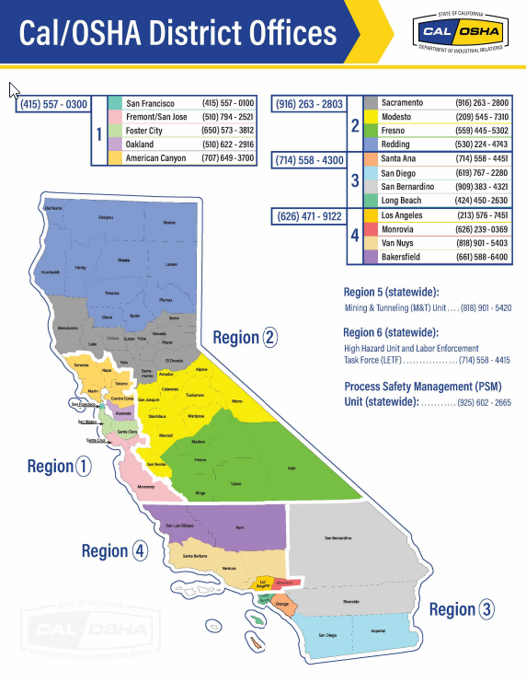

What to Report: Fill out as much as possible prior to reporting.

- Date and Time of Accident:______________________________________________
- List Organization Name, Address, and Phone Number ________________________
_______________________________________________________________________
- Person Reporting Accident Name and Job Title: _____________________________
_______________________________________________________________________
- Adress of accident site:_________________________________________________
- Name of Person to Contact at site:________________________________________
- Name and Address of Injured Employee(s):_________________________________
_______________________________________________________________________
- Nature of injury:_______________________________________________________
- Location where injured employee(s) was (were) moved to:______________________
_______________________________________________________________________
- List any law enforcement agencies present at the site of the accident: ____________________________________________________________________
- Description of the accident and whether the accident scene or instrumentality has been altered: _____________________________________________________________

Where to Report: (recommended filling out when adopting the form)
Local Cal/OSHA Office: __________________________ Phone Number: ______________
And/Or
Email: caloshaaccidentreport@tel-us.com

Document Reporting
When was the Incident Reported: Date: ___________________ Time:__________________
Name and title of person reporting: _______________________________________________
Signature of person that reported Incident: _________________________________________

