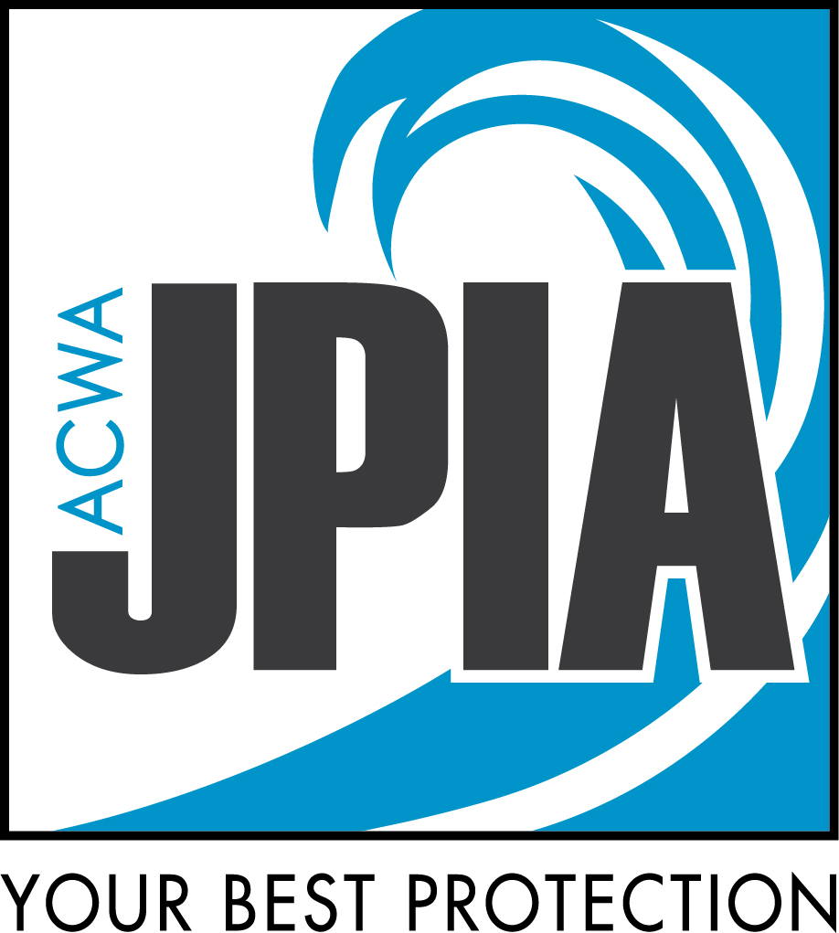
WORKERS’ COMPENSATION DEPARTMENT
Workers’ Compensation Injury Reporting Kit
What to do when an employee is hurt at work, and how ACWA JPIA works with you on the claim

ACWA JPIA Workers’ Compensation Claims
ACWA JPIA Workers’ Compensation Claims | Main phone: (916) 786-5742 or (800) 231‑5742
Email: claimswc@acwajpia.com | Workers’ comp fax: (916) 786-0209 | acwajpia.com/report-a-claim

WORKERS’ COMPENSATION DEPARTMENT | REPORTING KIT
What’s in This Kit
Each piece also works on its own, so you can share just the page you need

1 | Start Here
Quick Start: An Employee Was Hurt at Work
What to do in the first hours and days
2 | Workers’ Comp Basics
Workers’ Comp at a Glance
The life of a claim, benefits, and who does what
3 | When an Injury Happens
First Aid Only Claims
Where the line is, and what your agency handles
DWC-1 Claim Form: Who Fills Out What
Completing and signing the claim form
How to Complete Form 5020
Box-by-box guide to the report that starts the claim
4 | After You Report
Your Role in a Workers’ Compensation Claim
Working with your examiner, return to work, common questions
5 | Be Ready Before an Injury
Choosing and Evaluating Your Occupational Clinic
What to look for and how to evaluate a clinic
Predesignation of a Personal Physician
What employers need to know
24/7 Nurse Triage for Workplace Injuries
A free member benefit
6 | Forms and Contacts
 | Forms and Links: Where to find every form, and when to use it
 | Medical Service Order: Give to the clinic for the first visit
 | Pharmacy First Fill Form: Plus the MyMatrixx Pharmacy First Fill Form
 | Employee Injury Report and Offer of Medical Evaluation: Employee form
 | Using the Employee Injury Report: Member guide (internal use only)
 | Supervisor’s Accident-Incident Investigation Form
 | Your Workers’ Comp Claims Team: Who we are and how to reach us

Start with the Quick Start.
It walks you through the first hours and days after an injury and points you to the right piece of this kit for each step. When in doubt, call us. We would rather hear from you early.

WORKERS’ COMPENSATION DEPARTMENT | QUICK START
An Employee Was Hurt at Work: What to Do
Start here. Keep this page where your team can find it.

1. Get Care First
Emergency?  Call 911 or go to the nearest emergency room. Then come back to this page. | Enrolled in 24/7 Nurse Triage?  Call your dedicated line. The nurse will guide the employee and start your paperwork. | Everyone else  Provide first aid as needed and decide whether the injury is first aid only.
▼
2. Is It First Aid Only?
Use the First Aid Only guide. If you’re not sure, call us.
▼ |  |  |  |  | ▼
 | YES: FIRST AID ONLY  - Handle it in-house and keep a short record of what happened and the care given.  - Employee declines an evaluation? Use the Employee Injury Report and Offer of Medical Evaluation.  - Employee wants to file a claim, or you’d like ACWA JPIA to handle it? Follow the steps on the right.  - Symptoms get worse or more care is needed? Follow the steps on the right. |  |  |  |  | NO, OR NOT SURE  Treatment beyond first aid, lost time, or work restrictions  - Send the employee to your clinic with the Medical Service Order and the Pharmacy First Fill Form. Using Nurse Triage? The nurse’s pre-authorization replaces the MSO, but still give the employee the First Fill Form.  - Give the employee a DWC-1 claim form within one working day of learning about the injury.  - Send us the Form 5020 as soon as possible, no later than 5 days. Don’t wait for the DWC-1.  - When the DWC-1 comes back, sign and date it, give the employee a copy, and send it to us with or after the 5020. If it doesn’t come back, still send the 5020. We’ll open the claim.
Fast Track with 24/7 Nurse Triage by Company Nurse! The nurse pre-fills the DWC-1, Form 5020, and OSHA 301 for you. Complete the sections left for you, sign the 5020, and send it to us. That’s your report to ACWA JPIA.

Serious injury, illness, or death? Report it to Cal/OSHA immediately, no later than 8 hours. Examples include inpatient hospitalization, amputation, or loss of an eye. This is separate from reporting to JPIA. dir.ca.gov/dosh/report-accident-or-injury.html

KEY DEADLINES
8 hours  Cal/OSHA report  Serious injury, illness, or death only | 1 working day  DWC-1 to the employee  From when you learn of the injury | 5 days  Form 5020 to ACWA JPIA  As soon as possible, no later than 5 days

Your Agency’s Information (fill in and post)
Occupational clinic and phone | Nurse Triage line (if enrolled) | Your workers’ comp contact

Report to ACWA JPIA Workers’ Compensation
Online: acwajpia.com/report-a-claim/#workerscomp Email: claimswc@acwajpia.com Fax: (916) 786-0209
Questions? Call us: (916) 786-5742 or (800) 231-5742. When in doubt, report it and call.

WORKERS’ COMPENSATION DEPARTMENT | MEMBER GUIDE
Workers’ Comp at a Glance
What happens after an employee gets hurt, and who does what

Workers’ compensation is no-fault coverage for work-related injuries and illnesses. It provides medical care and certain benefits to an injured employee, regardless of who was at fault.
ACWA JPIA is a self-insured, self-administered risk-sharing pool. Our own Workers’ Compensation Claims Team manages claims for our members, so you work directly with us.
You manage your employee and your workplace. We manage the workers’ compensation claim. We work together throughout the process.
The Life of a Claim
1  Injury | 2  Report | 3  Investigation | 4  Treatment and recovery | 5  Return to work | 6  Resolution | 7  Closure
MEMBER LEADS | MEMBER LEADS | JPIA LEADS | JPIA LEADS | TOGETHER | JPIA LEADS | JPIA LEADS

1 | An Employee Gets Hurt  Focus on the employee first. Get emergency care when it’s needed. For non-emergency injuries, send the employee to your occupational clinic, or call your Nurse Triage line if your agency is enrolled. Then note the basics: what happened, when, where, who saw it, and whether the employee needs treatment or will miss work.  If the injury needs more than first aid or causes lost time, give the employee a claim form (DWC-1) within one working day of learning about it.
  REMEMBER
  Take care of the employee first. You don’t need to decide whether the injury is covered by workers’ compensation.
2 | Report the Injury to ACWA JPIA  Complete the Form 5020 and send it to us as soon as possible, no later than 5 days. The 5020 is what sets up the claim. Send what you have, even if you don’t have every detail, and follow up with the rest. Don’t hold the report while you try to figure out whether the injury is work-related.  What should I send?
  - Form 5020  - The DWC-1, if the employee returned it (with or after the 5020)  - Witness names and contact information  - Medical information | - Job description and work schedule  - Payroll and wage information, when requested  - Photos or video, if any  - Any concerns or unusual circumstances
3 | ACWA JPIA Takes It from Here  Once you report the claim, a ACWA JPIA claims examiner is assigned and takes responsibility for managing it. The examiner will:
  - Contact the people involved  - Review the injury information  - Coordinate medical care  - Investigate whether the injury is covered | - Determine and administer benefits  - Monitor disability and work status  - Keep the claim moving toward resolution

What “Accepted, Delayed, or Denied” Means
ACWA JPIA investigates every reported claim. Expect a request or two for information along the way. A timely response helps us reach a decision sooner.
Accepted  ACWA JPIA has determined the injury is covered by workers’ compensation (compensable) and administers the benefits that apply. | Delayed  ACWA JPIA needs more information before deciding. The claim is under investigation. This is not a denial. | Denied  Based on the investigation, ACWA JPIA has determined the injury is not covered (not compensable). The employee may challenge the decision through the workers’ compensation process.

GOOD TO KNOW
California law generally gives ACWA JPIA up to 90 days from the date the employee files a claim form to accept or deny the claim. While the claim is being investigated, the employee can still receive authorized medical treatment, up to $10,000.
Benefits an Employee May Receive
Which benefits apply depends on the injury and the claim. Your examiner will explain what applies.
Medical Care | Reasonable and necessary treatment for the work injury
Temporary Disability | Partial wage replacement while the employee can’t work during recovery
Permanent Disability | If the injury leaves a lasting impairment
Job Displacement Voucher | Help with retraining, in some cases when the employee can’t return to their job
Death Benefits | For eligible dependents if a work injury or illness is fatal
While the Employee Recovers
Your examiner manages the claim and the medical benefit process. You manage the employment relationship. As treatment continues, the treating doctor issues work status reports. Each one will say the employee can:
Return to regular work  No restrictions | Work with restrictions  Modified or limited duty | Stay off work  Temporarily

When the doctor issues restrictions, your agency decides whether work is available within them, following your own policies and accommodation obligations. Tell your examiner whether you can offer modified work and when it starts, or why it isn’t available. Never ask an employee to work outside the doctor’s restrictions. See Your Role in a Workers’ Compensation Claim for more on return to work.
As the Claim Moves Toward Closure
Not every claim follows the same path. Some resolve quickly. Others take longer because treatment continues, the employee has permanent restrictions or permanent disability, an attorney gets involved, or the claim moves toward settlement. Your examiner will let you know when your assistance is needed. A claim generally closes once the open issues are resolved.
KEEP IN MIND  Returning to work doesn’t necessarily close the claim. Medical treatment or other issues may continue after the employee is back on the job. |  | KEEP IN MIND  Future medical care may remain available. Depending on how a claim resolves, the employee may still be able to receive treatment for the injury.

You know your employees and your workplace. We know workers’ compensation. Together, we will make sure your employee gets the care and support they need.

Questions? Start With Your Claims Examiner.
ACWA JPIA Workers’ Compensation Claims | Main phone: (916) 786-5742 or (800) 231-5742
Email: claimswc@acwajpia.com | Workers’ comp fax: (916) 786-0209 | acwajpia.com

WORKERS’ COMPENSATION DEPARTMENT | MEMBER GUIDE
First Aid Only Claims
What qualifies, what doesn’t, and what your agency needs to do

Not every workplace injury becomes a workers’ compensation claim. A scraped knuckle that needs a bandage, or a bumped knee that needs an ice pack, can be handled as first aid only. The trouble starts when an injury looks minor but moves past first aid, and no one reports it.
This guide shows where the line is, what your agency handles as a first aid only case, or when to bring us in. If you’re unsure, call us.
The Short Version
- First aid only means minor, one-time treatment that appears on the first aid list in this guide.
- If a case is first aid only, your agency handles it, including the clinic bill. ACWA JPIA is not involved and can’t pay bills or respond to authorization requests.
- If anything goes beyond first aid, report it to ACWA JPIA right away. If you’re not sure, call us before you decide.
What Counts as First Aid Only
First aid is a one-time treatment, plus a follow-up visit to check on the injury, for something minor like a small cut, scrape, burn, or splinter. It’s still first aid if a doctor or nurse provides it. What matters is the treatment given, not who gave it or where.
The first aid list is short and specific. If the treatment isn’t on the list, the case is not first aid only. Start with these four questions.
Four quick questions
If you answer yes to any of these, the case is not first aid only. Report it to ACWA JPIA right away.
- Did the employee miss work beyond the shift when the injury happened, or get any work restrictions?
- Did anyone prescribe medication, give an injection other than a tetanus shot, or use stitches or staples?
- Was the employee sent to another facility for X-rays, scans, or other tests?
- Has the employee lost consciousness, been to the ER or hospital, or had more than two visits for the same injury?
The First Aid List at a Glance
Can Be First Aid Only: | Not First Aid Only: Report to ACWA JPIA
- Over-the-counter medication at non-prescription strength  - A tetanus shot  - Cleaning, flushing, or soaking a wound on the skin surface  - Bandages, gauze, Steri-Strips, or butterfly bandages  - Hot or cold therapy (ice or heat packs)  - Elastic wraps or other non-rigid supports  - A splint, sling, neck collar, or back board used only for transport  - Draining a blister, or relieving pressure under a nail  - An eye patch, or rinsing out a loose foreign object (not embedded)  - Removing a splinter or debris (not in the eye) with tweezers, rinsing, or a swab  - Finger guards or massage  - Drinking fluids to relieve heat stress | - Employee is taken off work beyond the shift when the injury happened  - Any work restrictions or modified duty  - Prescription medication, or a prescription filled at an outside pharmacy  - Any injection other than a tetanus shot  - Sent to another facility for X-rays, MRI, CT scans, or other tests, even if the first visit was only first aid  - Stitches or staples (Steri-Strips are fine)  - A rigid brace, cast, or splint used as treatment  - Physical therapy or chiropractic care  - Loss of consciousness, even briefly  - A broken or cracked bone, an emergency room visit, or a hospital stay  - More than two visits for the same injury  Rule of thumb: if the treatment isn’t on the first aid list, it isn’t first aid.

Where We See the Most Confusion
These situations come up often. In each one, the treatment may look small, but the case is no longer first aid only.
SITUATION | WHY IT GOES BEYOND FIRST AID
The employee is taken off work | Missing work beyond the shift when the injury happened means the case goes beyond first aid, even if all the treatment was a bandage and an ice pack. It doesn’t matter whether the provider or your agency sends the employee home, or whether the time is covered with sick leave or vacation. Report it right away.
The employee is given work restrictions | A restriction from the clinic, even something short like “no lifting over 10 pounds for two days,” takes the case out of first aid only. Report it right away so the clinic’s requests have somewhere to go.
The clinic writes a prescription | Prescription medication is medical treatment. That includes a prescription-strength version of a drug you can buy over the counter. If the employee is sent to a pharmacy to fill something, report it.
The employee gets an injection | A tetanus shot is the only injection that counts as first aid. Pain, steroid, or any other injection is medical treatment, so report it.
The employee is sent somewhere else for X-rays or scans | Say the employee is seen at your occupational clinic and the provider sends them to another location for X-rays or other tests. Even if the first visit was only first aid, the referral means the case goes beyond first aid. Report it right away.
Examples: First Aid Only or Not?
Everyday scenarios to use as a guide. If yours doesn’t fit neatly, call us.
SCENARIO | ANSWER | WHY
An employee cuts a finger. The cut is cleaned and bandaged, and the employee returns to regular duty. | First aid only | Cleaning and bandaging are on the first aid list.
An employee twists an ankle. The clinic applies ice and an elastic wrap, and the employee returns to regular duty. | First aid only | Cold therapy and elastic wraps are on the list, and there are no restrictions.
Same twisted ankle, but the clinic says light duty for three days. | Report it | Any work restriction goes beyond first aid, even when the treatment was only ice and a wrap.
A worker has a deep cut. The clinic closes it with stitches. | Report it | Stitches and staples are medical treatment. Steri-Strips are not.
An employee has wrist pain. The occupational clinic wraps it, then sends the employee to an imaging center for X-rays. | Report it | Being sent to another facility for X-rays goes beyond first aid, even if the first visit was only first aid.
An employee hits their head, feels dizzy, and briefly blacks out. | Report it | Any loss of consciousness goes beyond first aid.
A worker takes over-the-counter ibuprofen from the first aid kit for a sore back and finishes the shift. | First aid only, for now | Non-prescription medication at label strength is on the list. If the pain continues and the employee seeks more care, report it.
If It Is First Aid Only: What Your Agency Does
- Provide or arrange first aid. This can happen on site or at your occupational clinic.
- Tell the clinic it’s first aid only and that your agency is paying. Do this before or at the visit. Ask them to bill your agency directly, not ACWA JPIA, and to call you if the provider recommends anything more, such as restrictions, a prescription, or sending the employee elsewhere for X-rays or scans.
- Write it down. Keep a short record of who was hurt, when, what happened, what treatment was given, and whether the employee returned to regular duty. Store it with your other confidential injury records.
- Check in with the employee in a day or two. If the pain continues or the employee needs more treatment, it may no longer be first aid only.
- Pay the clinic bill. On a first-aid-only case, the bill is your agency’s to pay.

What ACWA JPIA can’t do on a first aid only case
A first aid only case isn’t set up as a claim with us, so we’re out of the loop. We can’t pay the clinic’s bill and we can’t respond to authorization requests. That’s why telling the clinic up front matters.
If It Goes Beyond First Aid: What to Do
- Report it to ACWA JPIA right away. Don’t wait for the clinic visit to wrap up or for paperwork. Send us the Form 5020 as soon as possible, no later than 5 days.
- Give the employee a claim form (DWC-1) within one working day of learning about the injury.
- Tell us the date you first learned of the injury and what treatment has been given so far. Deadlines run from the date your agency knew about the injury, so starting out as first aid doesn’t reset the clock.
- Keep your own record of what happened and what you did. We’ll let you know what else we need.
Why timing matters. Workers’ compensation deadlines start when your agency first learns about an injury, not when we do. A late report can delay the employee’s care and can put your agency at risk of missing deadlines, including the one-working-day claim form requirement. Reporting early is the best way to protect the employee and your agency, and it lets us help you from the start.
Who Does What at a Glance
 | First aid only | Beyond first aid
Report to ACWA JPIA? | Not required. Call us if you’re unsure. | Yes, right away.
Claim form (DWC-1) | Not required. If the employee asks for one, provide it and call us. | Give it to the employee within one working day of learning about the injury.
Clinic bill | Your agency pays. Tell the clinic up front. | ACWA JPIA handles it through the claim.
Authorization requests | ACWA JPIA can’t respond. A request usually means the case is beyond first aid. | ACWA JPIA reviews and responds.
Your written record | Keep a short internal record. | Keep your record and send us what we ask for.
OSHA 300 Log | Not recordable. | Generally recordable. Decide within 7 calendar days of learning about it.
Frequently Asked Questions
DECIDING WHETHER IT’S FIRST AID ONLY
Who decides whether an injury is first aid only?
Your agency makes the first call, using the lists in this guide. We don’t review first aid only cases, but we’re glad to talk one through with you.
Do we need to tell ACWA JPIA about first aid only cases?
No, not if your agency opts to handle the injury as first aid. If you’re unsure whether a case qualifies, call us before you decide.
Can the employee see a doctor or clinic and still be first aid only?
Yes. What counts is the treatment, not who provides it. A clinic visit can still be first aid only if the clinic does nothing beyond the first aid list and any follow-up is just to check on the injury.
How many visits are allowed?
One treatment visit and a follow-up to check on the injury. If treatment goes beyond two visits, report it.
The employee is off work, but all the treatment was first aid. Can we still call it first aid only?
No. Time off work beyond the shift when the injury happened means the case goes beyond first aid, even if every treatment was on the list. The same is true for work restrictions. Report it right away.
The employee went to their own doctor or urgent care. Does that change anything?
The test is the same: what treatment was given. If you learn the employee received a prescription, stitches, scans, restrictions, or time off, the case is beyond first aid. Report it as soon as you learn about it, and ask the employee to keep you updated.
WORKING WITH THE CLINIC
What should we tell the clinic?
Say something like: “This is a first aid only visit. Please bill our agency directly, not ACWA JPIA, and call us if the provider recommends anything beyond first aid.” Give them your agency’s billing contact so the bill goes to the right place.
The clinic billed ACWA JPIA. What now?
We can’t pay it on a first aid only case. Contact the clinic and ask them to redirect the bill to your agency. For next time, tell the clinic up front that your agency is the payer.
The clinic sent ACWA JPIA an authorization request. Why haven’t you responded?
We can’t act on authorization requests for a case handled as first aid only. A request like this usually means the provider wants to do more than first aid, such as an MRI, physical therapy, or a specialist referral. If that’s the case, report it to us right away.
WHEN THINGS CHANGE
The employee wants to file a claim, but it was just first aid. What do we do?
Employees have the right to file a claim. Give them a claim form (DWC-1) and let us know right away. Please don’t discourage them. Once a claim form is filed, the claim process runs on strict timelines.
We treated it as first aid, and now the employee is getting worse.
Report it right away. Tell us when the injury happened, what was done at first, and what has changed. Starting as first aid is fine. Waiting to report is the problem.
What if we’re just not sure?
Call us. We’d rather have a quick conversation early than sort out a missed report later.
RECORDKEEPING
Should we keep a record of first aid only incidents?
Yes. A short internal record of what happened, what treatment was given, and whether the employee returned to regular duty helps if the case changes later. Store it with your other confidential injury records.
Do we record first aid only cases on our OSHA 300 Log?
No. First aid only cases aren’t recordable. A case that goes beyond first aid generally is, and your agency has 7 calendar days from learning about it to decide and complete the OSHA 301 or an equivalent form. Recordkeeping is your agency’s responsibility and is separate from reporting a claim to us. Check with your safety or HR contact if you have questions.

Questions? We’re here to help.
ACWA JPIA Workers’ Compensation Claims | Main phone: (916) 786-5742 or (800) 231‑5742
Email: claimswc@acwajpia.com | Workers’ comp fax: (916) 786-0209 | acwajpia.com/report-a-claim
This guide is a general overview to help members and is not legal advice.

WORKERS’ COMPENSATION DEPARTMENT | MEMBER GUIDE
DWC-1 Claim Form: Who Fills Out What
A quick guide for member agency staff on completing and signing the form

Give the employee a DWC-1 within one working day of learning about a work-related injury or illness requiring more than first aid treatment or causing lost time beyond the date of injury. Knowledge can come from any source, not just the employee. Missing the deadline can lead to fines and loss of possible defenses. The form has two sections, and each person signs their own section.
EMPLOYEE’S SECTION  Top of the form |  | YOUR AGENCY’S SECTION  Bottom of the form
WHO FILLS IT OUT  The employee, if they wish to file a claim. Do not complete lines 2–9 for them.  Using 24/7 Nurse Triage? The nurse may pre-fill these lines from what the employee reported on the call. That’s expected. Give the form to the employee to review, correct or add to, and sign.  WHAT GOES HERE  - Lines 2–8: Contact information, date, time, and place of the injury, how it happened, and body parts affected  - Line 1: Today’s date  WHO SIGNS  The employee signs their own name on line 9. |  | WHO FILLS IT OUT  You, or another person your agency has authorized.  WHAT GOES HERE  When you give the employee the form:  - Line 1: Employee’s name only  - Lines 10–13: Your agency name, address, date you first knew of the injury, date you gave the employee the form  When the form comes back (15–16 are pre-filled):  - Lines 14, 18–19: Date you received the form, your title, and agency phone number with area code  WHO SIGNS  Your authorized representative signs only line 17.

NEVER SIGN THE EMPLOYEE’S NAME
No one at your agency may sign for the employee, including supervisors, managers, and HR. Do not type the name, add initials, or write “for employee.”

Step-by-Step:  - Complete line 1 and lines 10–13. Make a copy for your file.  - Give the employee the form. If they are not at work, mail it to their mailing address.  - The employee completes lines 2–8, today’s date on line 1, and signs line 9. Give them the Temporary Receipt copy.  - Complete lines 14 and 17–19.  - Give the employee the Employee copy, or mail it.  - Send the Claims Administrator copy to ACWA JPIA as soon as possible by mail, email, or fax, with the Form 5020 if you haven’t sent it yet. Keep the Employer copy. |  | If the Employee Can’t or Won’t Sign:  - Leave line 9 blank. Do not sign for them.  - Complete your lines and sign line 17.  - Write down the date you gave the employee the form and why it is not signed. For example, “employee declined to sign.”  - Send the form to us anyway, with or after the Form 5020. A missing employee signature is not a reason to hold the form or refuse it.  Keep a record  - Note each date: injury reported, form given, form returned, form sent to ACWA JPIA.

Questions? Call us.
ACWA JPIA Workers’ Compensation Claims | Main phone: (916) 786-5742 or (800) 231‑5742
Email: claimswc@acwajpia.com | Workers’ comp fax: (916) 786-0209 | acwajpia.com/report-a-claim

WORKERS’ COMPENSATION DEPARTMENT | MEMBER GUIDE
How to Complete Form 5020
Employer’s Report of Occupational Injury or Illness

The 5020 is completed by your agency’s workers’ compensation claims contact, not the employee. It is what sets up the claim with ACWA JPIA. File it as soon as possible, no later than 5 days after you learn of any work-related injury or illness that involves death, lost time beyond the date of injury, restricted duty, or medical treatment beyond first aid. Not sure if it’s work-related? Report it, and we’ll review it with you.
Use the fill-in form on acwajpia.com and enter dates as mm/dd/yy. Boxes highlighted in yellow need a little extra attention. Unsure about any box? Call us. We’re glad to help.
EMPLOYER INFORMATION: Boxes 1–6
1 | Firm Name | Agency’s full legal name.
1a | Policy Number | Enter Self-Insured.
2 / 2a | Mailing Address/Phone | Agency mailing address and main phone number, including area code.
3 / 3a | Location/Location Code | Complete Box 3 only if the work location differs from the mailing address. Enter N/A in 3a.
4 | Nature of Business | Type of agency, such as Water Utility, Wastewater Utility, or Public Utility District.
5 | State Unemployment Ins. Acct. No. | Leave blank.
6 | Type of Employer | Check Other Gov’t and write Special District.

INJURY/ILLNESS INFORMATION: Boxes 7–29
7 | Date of Injury/Onset of Illness | Date the injury occurred or the illness began. Cumulative trauma dates can be complex. Call us before completing this box, and we’ll help you sort it out.
8 / 9 | Time Injury Occurred/Time Employee Began Work | Enter each time and select AM or PM.
10 | Date of Death | Only if the employee died. If an employee later dies from a previously reported injury, file an amended 5020 within 5 days of knowledge.
11 | Unable to Work at Least One Full Day After Injury? | Yes or No.
12–14 | Date Last Worked/Returned/Still Off | Complete only if the employee lost time. Enter the last day worked and the return-to-work date. If the employee has not returned, check the Box 14 “still off work” box.
15 | Paid Full Day’s Wages for Date of Injury or Last Day Worked? | Yes, if the employee received full pay for the day of injury (or the last day worked). Otherwise, No.
16 | Salary Being Continued? | Check No in most cases. Accrued sick time, vacation, or PTO is not salary continuation, even when used for the 3-day waiting period. Check Yes only if your agency has a formal, employer-funded salary continuation plan. Letting an employee use leave doesn’t change the benefits ACWA JPIA owes. Not sure? Call us.
17 | Date of Employer’s Knowledge | First date anyone acting for the agency learned of the injury or a possible work-related claim, from any source. Must match DWC-1 Box 12.
18 | Date Employee Was Provided Claim Form | Date the DWC-1 was given or mailed to the employee (due within 1 working day of knowledge). Must match DWC-1 Box 13.
19 | Specific Injury/Illness and Part of Body | The injury and body part. Add the diagnosis if you have it. Example: Strain, right shoulder.
20 / 20a | Location Where Event Occurred/County | Street address, city, zip, and county where the injury or exposure happened.
21–23 | On Premises? Department? Others Injured? | Yes or No for 21 and 23. For 22, name the department or work area where it happened.
24 | Equipment, Materials, Chemicals | What the employee was using or working with when it happened. Example: 36-inch valve wrench.
25 | Specific Activity | What the employee was doing right before the injury. Example: Turning an underground water valve.
26 | How Injury/Illness Occurred | The sequence of events, in plain, factual terms. Name the object or exposure that caused the injury. Use a separate sheet if needed. Example: Employee was pulling a valve wrench toward his body when he felt a sudden pain in his right shoulder.
27–29 | Physician/Hospital/Emergency Room | 27: Treating physician’s name, address, and phone. 28: Yes, if hospitalized as an inpatient overnight; if so, add hospital name, address, and phone. 29: Yes or No.

EMPLOYEE INFORMATION: Boxes 30–39
30–32 | Name/SSN/Date of Birth | Employee’s full name, Social Security number, and date of birth.
33 / 33a | Home Address/Home Phone | Full home address, and the employee’s home phone number with area code.
34 / 36 | Sex/Date of Hire | Select Male or Female. Enter the date of hire.
35 | Occupation | The employee’s specific job title. No initials, abbreviations, or numbers.
37 / 37a | Employee Usually Works/Employment Status | Hours per day, days per week, and total weekly hours. Then check regular full-time, part-time, temporary, or seasonal.
37b | Class Code Where Wages Are Assigned | The workers’ compensation class code your agency reports for this employee’s payroll. It is the same code used to calculate your ACWA JPIA contributions. Not sure which one applies? Call us.
38 / 39 | Gross Wages/Other Payments | Gross pay and the pay period (per hour, week, month). Box 39: Yes, if the employee gets extra payments not included in Box 38, such as tips, meals, or bonuses.
Sign | Completed By | Print your name, then sign with your title and date. The person completing the form must sign it.

Before You Submit
- Review the form for blank boxes. Confirm Boxes 17 and 18 match DWC-1 Boxes 12 and 13. Sign and date it.
- Send it to ACWA JPIA as soon as possible, no later than 5 days: online at acwajpia.com/report-a-claim, by secure email to claimswc@acwajpia.com, or by fax to (916) 786-0209. If you’d like extra security on your end, you can also use the Secure Message Portal on our report-a-claim page. Don’t send reports to DIR, the WCAB, an attorney, or a physician.
- Don’t hold the 5020 for the DWC-1 or the Supervisor’s Accident-Incident Investigation. Send those as soon as you can.
- Using Nurse Triage? The nurse pre-fills much of the 5020. Review every box with this guide, complete the rest, and sign it.
- Serious injury, illness, or death? Report it to Cal/OSHA immediately, and no later than 8 hours. That’s separate from the 5020.

Not sure how to answer a box? We’re glad to help.
ACWA JPIA Workers’ Compensation Claims | Main phone: (916) 786-5742 or (800) 231‑5742
Email: claimswc@acwajpia.com | Workers’ comp fax: (916) 786-0209 | acwajpia.com/report-a-claim

WORKERS’ COMPENSATION DEPARTMENT | MEMBER GUIDE
Your Role in a Workers’ Compensation Claim
What ACWA JPIA members need to know, and do, when an employee is hurt at work

ACWA JPIA is a risk pool, not an insurance company. Our own Workers’ Compensation Claims Team administers your claims, so there is no outside carrier or third-party administrator to call. You work directly with us. This guide explains what you do when an employee is hurt at work, what we do, and how we work together.
This is a partnership.
You know your employees, your workplace, and your witnesses. Our team handles the claims process and California’s workers’ compensation requirements. Claims go best when we share information early and stay in close contact. If you are ever unsure what to do, call us. We would rather hear from you sooner than later.
Who Does What
You (the Member) | ACWA JPIA Claims Team
- Gives the employee a claim form and sends us the Form 5020 and completed claim form  - Reports the injury to us as soon as possible  - Shares facts, witnesses, and documents  - Manages the workplace and directs the employee to care  - Offers modified work when possible  - Tells us about changes in pay or job status | - Sets up and manages the claim, and keeps you updated  - Investigates and decides to accept or deny it  - Handles treatment authorizations and medical bills  - Pays workers’ comp benefits when due  - Reviews medical reports and work restrictions  - Handles attorneys and disputes
When an Employee Reports an Injury: Five Steps
1 | Get medical help first.  For an emergency, call 911 or go to the nearest emergency room. Otherwise, send the employee to your designated clinic, or to their pre-designated physician if one is on file. If your agency uses 24/7 Nurse Triage, call your dedicated line first.
2 | Give the employee a claim form (DWC-1).  Do this within one working day of learning about an injury that needs more than first aid or causes lost time. Never refuse the form, even if you doubt the injury is work-related.
3 | Complete the Employer’s Report of Injury (Form 5020) and send it to us.  If you are sending the employee for care beyond first aid, fill out the form with what you know now and send it to ACWA JPIA as soon as possible, no later than 5 days. Don’t wait for the DWC-1 to come back or for your own investigation.
4 | Complete the employer section of the DWC-1.  When the employee returns the claim form, sign and date it, give the employee a copy, and send it to ACWA JPIA as soon as possible.
5 | Stay in touch.  Respond to examiner requests in a timely manner. Send us medical notes, restrictions, bills, and letters as soon as reasonably possible, and tell us about changes in work status.

Why Speed Matters
California law puts ACWA JPIA on a clock. We generally have 90 days to accept or deny a claim, and the clock starts when the employee gives you the claim form, not when you send it to us. If we miss the deadline, the claim can be presumed compensable (accepted) by law. Late reports also tend to make claims cost more.
If You Question Whether an Injury Is Work-Related
Report the claim and give us the facts. Do not make the decision yourself. Tell your examiner what concerns you, who saw what happened, and who we should interview.
Please don’t refuse the claim form, discourage the employee from filing, delay medical care, or tell the employee the claim is denied. Avoid promising benefits or outcomes. You tell us what you know. We investigate and decide.
What We Need From You  - Employee name, contact information, job, and schedule  - Date, time, and place of the injury, and what happened  - Body parts involved and any treatment so far  - Supervisor and witness names  - Incident reports, photos, or video  - Wage and payroll information  - Job description and physical requirements  - Any concerns about how the injury happened |  | Call Your Examiner When…  - The employee misses work or gets new work restrictions  - The employee is hospitalized or surgery is recommended  - The employee hires an attorney, or you receive legal papers  - The employee returns to work, refuses offered work, or leaves employment  - Pay, job duties, or work availability change  - You learn something new about how the injury happened  - You aren’t sure what to do. Call early.
Return to Work
The treating doctor decides what the employee can safely do. Your agency decides whether work is available within those restrictions, following your own policies and accommodation obligations. For guidance on a consistent return-to-work program, see ACWA JPIA’s Human Resources Best Practices.
These details affect the benefits we owe, so please:
- Send us each work status report as soon as you receive it.
- Tell your examiner if you can offer modified work and when it starts, or why it isn’t available.
- Let us know as soon as possible if the employee returns to full duty, declines offered work, or stops working.
- Check with your examiner before paying sick leave, vacation, or salary in place of benefits.
Tip: track modified duty as it happens. Record the start and end dates and the restrictions in place. It helps with your own recordkeeping, and it helps you and your examiner spot temporary modified duty that has run longer than expected.
Common Questions
The employee says they don’t want to file a claim. Do we still report it?
Maybe. Call us and we will talk it through. Every situation is different. Sometimes you may be comfortable letting it go, and other times you will want the employee evaluated. We can help you sort out which applies.
Where does the employee go for treatment?
ACWA JPIA does not keep pre-designation forms, so check your personnel files before sending an employee for care. Send any medical bills or provider calls to your examiner.
Can we discipline or terminate an employee who has a claim?
Employment decisions are yours, but California law prohibits discrimination against an employee for filing a workers’ compensation claim. Talk with your legal counsel or HR advisor before acting.
We received an attorney letter or court papers. What now?
Send them to your examiner as soon as possible so we can coordinate the response. Please don’t reply to the attorney or agency on your own.

Questions? Call Us.
ACWA JPIA Workers’ Compensation Claims | Main phone: (916) 786-5742 or (800) 231‑5742
Email: claimswc@acwajpia.com | Workers’ comp fax: (916) 786-0209 | acwajpia.com/report-a-claim

WORKERS’ COMPENSATION DEPARTMENT | MEMBER GUIDE
Choosing and Evaluating Your Occupational Clinic
Tips for ACWA JPIA member agencies

Choosing an occupational clinic is one of the most useful things your agency can do before an injury happens. Because ACWA JPIA does not use a Medical Provider Network (MPN), a fixed list of approved doctors, you have the flexibility to select the clinic that best fits your employees and operations. We encourage you to build a strong relationship with that clinic, and this guide offers tips to evaluate your current clinic or a new one. When employees know where to go and the clinic understands your agency, injured workers get care sooner.
How Medical Control Works Without an MPN
- Your agency selects the clinic for the first 30 days after an injury is reported. After that, the employee may generally choose their own treating physician.
- Predesignation is the exception. If an employee has a valid Predesignation of Personal Physician on file before the injury, that employee treats with the designated doctor from the start (see below).
- Emergencies: call 911 or go to the nearest emergency room, then follow up with your designated clinic.
What to Look for in a Clinic
The ACWA JPIA Clinic Evaluation Form has 43 questions. These are the areas that matter most.
Area | What to look for and ask
Access and after hours | Hours that fit your shifts, including early starts and weekends. Walk-in visits, same-day urgent care, and typical wait times.  Ask about after hours. When employees are hurt outside clinic hours, does the clinic recommend a secondary clinic, or is the emergency room preferred? Share the answer with employees.
Return to work and accommodation | Ask about the clinic’s philosophy on return to work. If you want the best chance to accommodate an injured employee, say so directly. Tell the clinic you want the opportunity to offer modified duty in any way you can, and share job descriptions.  Look for clear work status and restrictions at every visit, sent promptly to you and your claims examiner, and a call to you before a doctor takes an employee off work.
Communication | A named staff contact who returns calls and reaches out when something unexpected happens, and doctors willing to answer questions.
Workers’ comp experience | How much of the practice is workers’ compensation, and are any physicians board certified in occupational medicine? Does the clinic know California reporting requirements, such as the Doctor’s First Report (due within five working days of the first visit)?
Credentials and history | Verify each physician’s license on the Medical Board of California website. Ask about malpractice history, board complaints, and sanctions. Check the Division of Workers’ Compensation list of suspended or terminated providers. Ask whether the doctors can write final (permanent and stationary) reports that meet AMA Guides rating standards.
Quality of care | Evidence-based treatment, a change in course when recovery stalls, timely specialist referrals, and access to therapy and imaging. Ask what results the clinic tracks.
Other services | Does the clinic also handle non-injury services such as DOT physicals, pre-employment drug screens, and respirator fit testing? One clinic for screening and injury care simplifies your workflow and strengthens the partnership. For drug and alcohol testing, confirm a dedicated collection restroom and an assigned medical review officer (MRO).
Tips for running the evaluation
- Go in person. Meet the lead physician and the clinic administrator, and see whether the facility is clean and organized.
- Use the Clinic Evaluation Form as a guide. You do not need to complete every box. Focus on what matters for your agency.
- Look for the best available clinic. Physicians are not evenly distributed across California, so choose from the providers actually in your area.
- Ask for references. Talk with other public agencies that use the clinic and with employees who have been treated there.
- Involve your team. Bring in HR, safety, and a supervisor. Your ACWA JPIA claims team can share how the clinic’s reports and communication have worked in practice, and we are glad to talk through what you find.
- Revisit it. Review the relationship at least once a year and after any problem claim. Keep a backup clinic in mind.
Predesignation of a personal physician
Before an injury, an employee can give you written notice that they want their personal physician to treat them for a work injury. When the requirements are met, your agency does not control that employee’s medical treatment. All of these must be true:
- On the date of injury, the employee has health coverage for non-work injuries and illnesses.
- The doctor (M.D., D.O., or medical group) is the employee’s regular physician, has previously directed the employee’s treatment, and keeps the medical records. The doctor must be a general practitioner or a board-certified or board-eligible internist, pediatrician, obstetrician-gynecologist, or family practitioner. A medical group can qualify if it is an integrated multispecialty group providing care mainly for non-work illnesses and injuries.
- Before the injury, the doctor agreed to treat the employee for work injuries.
- Before the injury, the employee gave you written notice with the doctor’s name and business address.
Employees can use DWC Form 9783 for this notice. The physician is not required to sign it, but if the physician does not, other documentation of the doctor’s agreement is required (Title 8, California Code of Regulations, section 9780.1(a)(3)). See our Predesignation of a Personal Physician guide for more.
What your agency should do
- Keep DWC Form 9783 available, and keep signed forms where whoever handles injury response can find them quickly.
- Check for a predesignation before you direct an injured employee to your clinic.
- If you are unsure whether one is valid, call your ACWA JPIA claims examiner before the employee is treated. We are happy to help.
Make sure employees know where to go
- Post the clinic’s name, address, phone number, hours, and after-hours instructions where employees will see them, such as break rooms and yards.
- Give the same information to new hires and supervisors, and give the clinic your reporting contacts.

Questions? Call us.
ACWA JPIA Workers’ Compensation Claims | Main phone: (916) 786-5742 or (800) 231‑5742
Email: claimswc@acwajpia.com | Workers’ comp fax: (916) 786-0209 | acwajpia.com/report-a-claim

WORKERS’ COMPENSATION DEPARTMENT | MEMBER GUIDE
Predesignation of a Personal Physician
What employers need to know: a plain-language guide for ACWA JPIA member agencies

Many employees have a doctor they know and trust. In California, an employee may be able to see that doctor for a work injury, but only if the right steps are taken before the injury happens. This is called predesignation. ACWA JPIA does not have an MPN or HCO, so this guide explains how predesignation works in that situation and points you to the official state forms.
Different rules may apply to employers that have an MPN or HCO. Those rules are not covered here.
What Does Predesignation Mean?
Predesignation means an employee names a personal physician ahead of time, before any work injury. If the legal requirements are met, that physician can treat the employee for a future work-related injury or illness.
Without a valid predesignation, the employer or claims administrator usually decides where the employee gets treatment at first. A valid predesignation can allow the employee to be treated by the named physician instead of going through that normal initial process.
Timing matters. The steps must be completed before the injury. An employee generally cannot wait until after getting hurt and then name a physician.
Who Can Be Predesignated?
Not every doctor qualifies. For a personal physician predesignation to be valid, all four of the following must be true:
- Health care coverage. The employee has health care coverage for non-work-related injuries or illnesses on the date of injury.
- Regular physician. The doctor is the employee’s regular physician and primary care physician, such as a general practitioner, family practitioner, internist, pediatrician, or OB-GYN. The doctor has previously directed the employee’s medical treatment and has kept the employee’s medical records. A qualifying medical group may also be designated under the applicable requirements.
- Physician agreement. The physician agreed, before the injury, to treat the employee for a work-related injury or illness.
- Written notice. Before the injury, the employee told the employer in writing that the employee wants this physician to provide treatment. The notice includes the physician’s name and business address.
Employees may use DWC Form 9783, Notice of Predesignation of Personal Physician, to give this notice. The physician may sign the form to show agreement. If the physician or medical group does not sign it, the employee needs other documentation showing the physician agreed to the predesignation.
Practical tip
If an employee gives you a predesignation, keep a copy of the form and any documentation of the physician’s agreement in the employee’s file. Note the date you received it. If a work injury is later reported, share these documents with ACWA JPIA as soon as possible.
When Does the Employee Need to Do This?
Before the injury. This is the most important point. The written notice, the physician’s agreement, and the employee’s health care coverage all need to be in place before the work injury happens.
If an employee names a doctor after being hurt, that is generally too late for a personal physician predesignation. The employee cannot go back and predesignate after the fact. If this situation comes up, contact ACWA JPIA for guidance.
Does the Form Need to Be Completed Every Year?
Generally, no. In the situation covered here (no MPN and no HCO), there is generally no requirement for employees to complete a new predesignation form just because another year has passed.
What employers do need to do is give employees information about their workers’ compensation medical-care rights, including information about predesignation, as California law requires. New employees generally receive this information when they are hired or by the end of the first pay period.
An employee who wants to change the designated physician should give the employer a new valid designation before an injury occurs.
What Happens if an Employee Does Not Predesignate a Physician?
When there is no valid predesignation and the employer does not have an MPN, the employer or claims administrator generally has the right to select and control medical treatment during the first 30 days after the employer learns of the injury. After that period, the employee generally has additional rights to select a treating physician, subject to workers’ compensation requirements.
A valid predesignation changes the starting point. The employee may receive treatment from the predesignated physician instead of going through the normal initial employer-selected treatment process.
Two Different California Forms
The state has two predesignation-related forms. They serve different purposes and do not give the employee the same rights. Please do not treat them as interchangeable.
 | DWC Form 9783 | DWC Form 9783.1
Form name | Predesignation of Personal Physician | Notice of Personal Chiropractor or Personal Acupuncturist
Who it covers | A qualifying personal M.D., D.O., or qualifying medical group | A personal chiropractor or personal acupuncturist
What the employee provides | Written notice before the injury, plus the physician’s agreement to treat work injuries | The provider’s name and business address, in writing, before the injury
After an injury | If all requirements are met, the employee may be treated by the predesignated physician instead of the normal initial employer-selected process | The claims administrator generally selects treatment for the first 30 days. Afterward, the employee may request a transfer to the named provider
DWC Form 9783: Predesignation of Personal Physician
This is the form for predesignating a qualifying personal M.D., D.O., or qualifying medical group. In plain terms, the employee needs health care coverage for non-work-related injuries or illnesses on the date of injury, a regular physician who has directed the employee’s care and kept the employee’s medical records, that physician’s agreement to treat a work injury, and written notice to the employer with the physician’s name and business address. The designation and the physician’s agreement must both happen before the work injury.
DWC Form 9783.1: Notice of Personal Chiropractor or Personal Acupuncturist
This form is different from the personal physician form. It applies when the employer or the employer’s insurer does not have an MPN. Before the injury, the employee gives the employer the chiropractor’s or acupuncturist’s name and business address in writing.
This form does not let the employee start treatment with the chiropractor or acupuncturist right after an injury. The claims administrator generally keeps the right to select the treating physician during the first 30 days after the employer knows about the injury. Once the claims administrator has started treatment with another doctor during that period, the employee may ask to transfer treatment to the chiropractor or acupuncturist named earlier.
California law also limits the number of chiropractic visits for applicable injuries. Employees should review the form and the applicable workers’ compensation rules for details.
Common mix-up
Form 9783.1 does not predesignate a physician, and it does not give the employee the same rights as Form 9783. An employee who turns in Form 9783.1 has identified a chiropractor or acupuncturist, not a personal physician.
Where to Find the State Forms
The California Department of Industrial Relations, Division of Workers’ Compensation (DWC) publishes the official forms. Go to the DWC forms page at dir.ca.gov/dwc/forms.html and look under “Pre-Designation” for:
- DWC Form 9783: Predesignation of Personal Physician
- DWC Form 9783.1: Notice of Personal Chiropractor or Personal Acupuncturist
Please use the official state forms rather than creating substitute forms. The DWC may update its forms from time to time, so download the current version from the DWC website.
Key Takeaways
- Predesignation happens before an injury.
- Not every doctor qualifies as a personal physician for predesignation.
- The physician must agree before the injury.
- A new form is not generally required every year simply because another year has passed in the non-MPN/non-HCO situation addressed here.
- Forms 9783 and 9783.1 serve different purposes.
- The official forms are available from the California DWC.

Questions? Call Us.
ACWA JPIA Workers’ Compensation Claims | Main phone: (916) 786-5742 or (800) 231‑5742
Email: claimswc@acwajpia.com | Workers’ comp fax: (916) 786-0209 | acwajpia.com/report-a-claim
This guide is a general overview of California workers’ compensation requirements. Specific circumstances may affect an employee’s medical-treatment rights. For questions about a particular employee or claim, contact ACWA JPIA or your legal counsel.

WORKERS’ COMPENSATION DEPARTMENT | MEMBER BENEFIT
24/7 Nurse Triage for Workplace Injuries
Immediate, expert injury guidance included with your ACWA JPIA Workers’ Compensation Program membership, at no additional cost

Workplace injuries happen. ACWA JPIA is pleased to make 24/7 Nurse Triage, provided by Company Nurse, available to all Workers’ Compensation Program members at no additional cost. The program gives your agency a dedicated toll-free number, customized to fit your reporting procedures.
Program Benefits
- Immediate access to a registered nurse, 24 hours a day, 7 days a week, including evenings, weekends, and holidays  - A dedicated phone number for your agency, customized to fit your reporting process  - Earlier injury reporting and notification to designated agency contacts  - Consistent injury documentation while the details are still fresh |  | - Required workers’ compensation paperwork is started for you, with key information pre-filled on the DWC-1, Form 5020, and OSHA Form 301  - Immediate guidance for employees following an injury, including after-hours incidents when agency staff may not be available  - Direction to your agency’s designated occupational medical provider when treatment is appropriate, with a pre-authorization sent to the clinic  - Fully flexible and customized to your agency’s reporting contacts, preferred providers, and preferences
How It Works
1  Injury occurs and the employee or supervisor calls the dedicated number | 2  A registered nurse takes the report and provides expert triage | 3  The nurse recommends self-care or refers the employee for medical treatment | 4  Your agency receives incident documentation and partially pre-filled forms. If treatment is recommended, the report is also sent to ACWA JPIA

The nurse’s report is not your report to ACWA JPIA
The nurse pre-fills the DWC-1, Form 5020, and OSHA 301 for you. Complete the sections left for you, sign the 5020, and send it to us. That’s your report to ACWA JPIA. When the nurse sends a pre-authorization to your clinic, you don’t need a Medical Service Order, but still give the employee the Pharmacy First Fill Form.
Results for Members
15 to 20%  Reduction in claims | 30%  Cost reduction (fewer unnecessary ER visits) | 40%  Resolved with self-care advice
Averages based on outcomes reported by Company Nurse, powered by Lintelio.
Ready to enroll your agency?
Contact your ACWA JPIA Workers’ Compensation Claims Manager. We’ll connect you directly with Company Nurse to set up your agency’s dedicated line, reporting contacts, and preferred medical providers at no cost to your agency.
Erin Bowles, Workers’ Compensation Claims Manager | (916) 232-9242 (direct) | ebowles@acwajpia.com

WORKERS’ COMPENSATION DEPARTMENT | MEMBER GUIDE
Forms and Links
Where to find every form in this kit, and when to use it

All ACWA JPIA forms are on our website: acwajpia.com/report-a-claim/#workerscomp
Download a fresh copy each time so you’re always using the current version.
Forms
Form | When to use it | Completed by | Where to get it
Form 5020: Employer’s Report of Occupational Injury or Illness | Starts the claim with ACWA JPIA. Send it as soon as possible, no later than 5 days. Don’t wait for the DWC-1. A fill-in version is available. | Agency | JPIA website
DWC-1 Claim Form | Give to the employee within one working day for an injury that needs more than first aid or causes lost time. Send it to ACWA JPIA with or after the 5020. A fill-in version is available. | Employee and agency | JPIA website  or DWC forms page  JPIA also mails printed sets
Medical Service Order | Give to the clinic. Authorizes the first visit. Not needed when a Nurse Triage nurse sends a pre-authorization to the clinic. | Agency | JPIA website
Pharmacy First Fill Form | Give a blank form to any employee sent to the clinic for treatment beyond first aid. The employee completes it at the pharmacy. | Employee | JPIA website
Employee Injury Report and Offer of Medical Evaluation | Optional. Records the employee’s account and their response to your offer of a medical evaluation. | Employee and agency | JPIA website
Supervisor’s Accident-Incident Investigation Form | Documents what happened and how to prevent it. Don’t hold the 5020 for it. | Supervisor | JPIA website
Clinic Evaluation Form | Helps you evaluate a current or new occupational clinic, before an injury happens. | Agency | JPIA website
DWC Form 9783 and 9783.1: Predesignation | Lets an employee name a personal physician, chiropractor, or acupuncturist before an injury. | Employee | DWC forms page

Helpful links
Report a claim online | acwajpia.com/report-a-claim/#workerscomp
State workers’ comp forms | dir.ca.gov/dwc/forms.html
Cal/OSHA serious injury reporting | dir.ca.gov/dosh/report-accident-or-injury.html Serious injury, illness, or death: report within 8 hours.
Find a MyMatrixx pharmacy | mymatrixx.com or call 800-945-5951 (24/7)
Return-to-work program guidance | ACWA JPIA’s Human Resources Best Practices at acwajpia.com (member login required)

Can’t find a form? Call us at (916) 786-5742 or (800) 231‑5742, or email claimswc@acwajpia.com.
Report a claim: online at the link above | claimswc@acwajpia.com | Workers’ comp fax: (916) 786-0209
Sending something sensitive? Use the Secure Message Portal on our report-a-claim page.

WORKERS’ COMPENSATION DEPARTMENT | FOR THE TREATING PROVIDER
Medical Service Order
ACWA Joint Powers Insurance Authority

Provider
Doctor or clinic name | Address

Employee
The employee named below was injured while in our employ. Please render necessary medical treatment immediately.
Employee name | Date of injury | Time of injury

Please complete and forward the Doctor’s First Report of Occupational Injury or Illness to:
ACWA Joint Powers Insurance Authority
c/o Manageware
PO Box 6510, Mesa, AZ 85216
Phone: (800) 231-5742 Fax: (916) 786-0209
Provider fax for RFA intake: (602) 536-0905
Please send the employee’s work status and any restrictions to the employer after each visit.

Employer
Employer | Address
Agency contact | Agency contact phone
Employer representative |  | Date

This order authorizes the initial visit only. Call ACWA JPIA at (800) 231‑5742 to authorize further treatment.

WORKERS’ COMPENSATION DEPARTMENT | MEMBER GUIDE
Pharmacy First Fill Form
Helping an injured employee fill prescriptions before their claim is set up

An employee sent to the clinic may leave with a prescription the same day. At that point, their claim usually isn’t set up yet. Before the employee can get a permanent pharmacy card, ACWA JPIA has to set up the claim and assign a claim number. We then send the employee’s information to our pharmacy benefit manager, MyMatrixx (an Evernorth company). That takes time.
The Pharmacy First Fill Form bridges that gap. It lets the employee fill prescriptions for the work injury at a participating pharmacy while their claim is being set up, without paying out of pocket.
When to Give It
Give the employee the First Fill Form, along with the Medical Service Order, any time you send them to the clinic for treatment beyond first aid.
Using 24/7 Nurse Triage? The nurse’s pre-authorization to the clinic replaces the Medical Service Order, but the employee still needs the First Fill Form.
What to Do
- Give the employee a blank form before they leave for the clinic. You can hand it to them, or text or email it. You don’t need to fill anything in.
- The employee completes it at the pharmacy. They give their own information, including the temporary ID number, directly to the pharmacy the first time they fill a prescription for this injury.
- Report the claim to ACWA JPIA as soon as possible. Send us the Form 5020 no later than 5 days. You don’t need to wait for the clinic visit to finish.
If the Employee Needs Help
MyMatrixx Patient Care Contact Center: 800-945-5951, available 24/7. They can help find a participating pharmacy or sort out a problem at the counter. Employees can also search for a pharmacy at mymatrixx.com.

The sooner you report, the sooner the card arrives.
The First Fill Form is a short-term bridge. Once we’ve received your report and set up the claim, MyMatrixx sends the employee a welcome letter and a permanent pharmacy card, and makes an automated welcome call.

Questions? Call Us.
ACWA JPIA Workers’ Compensation Claims | Main phone: (916) 786-5742 or (800) 231‑5742
Email: claimswc@acwajpia.com | Workers’ comp fax: (916) 786-0209 | acwajpia.com/report-a-claim

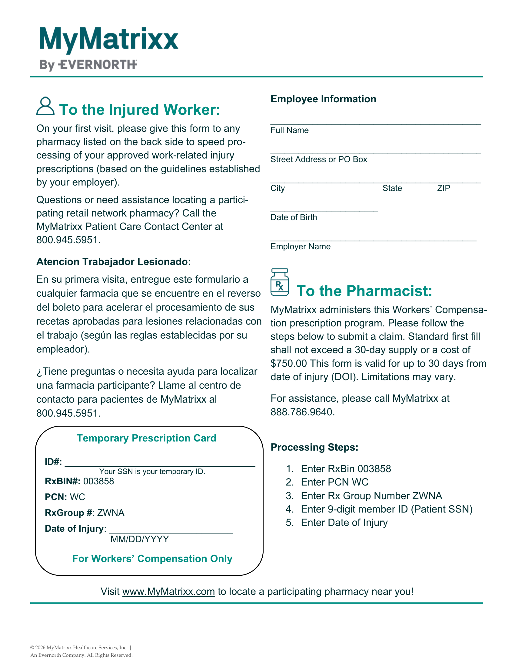

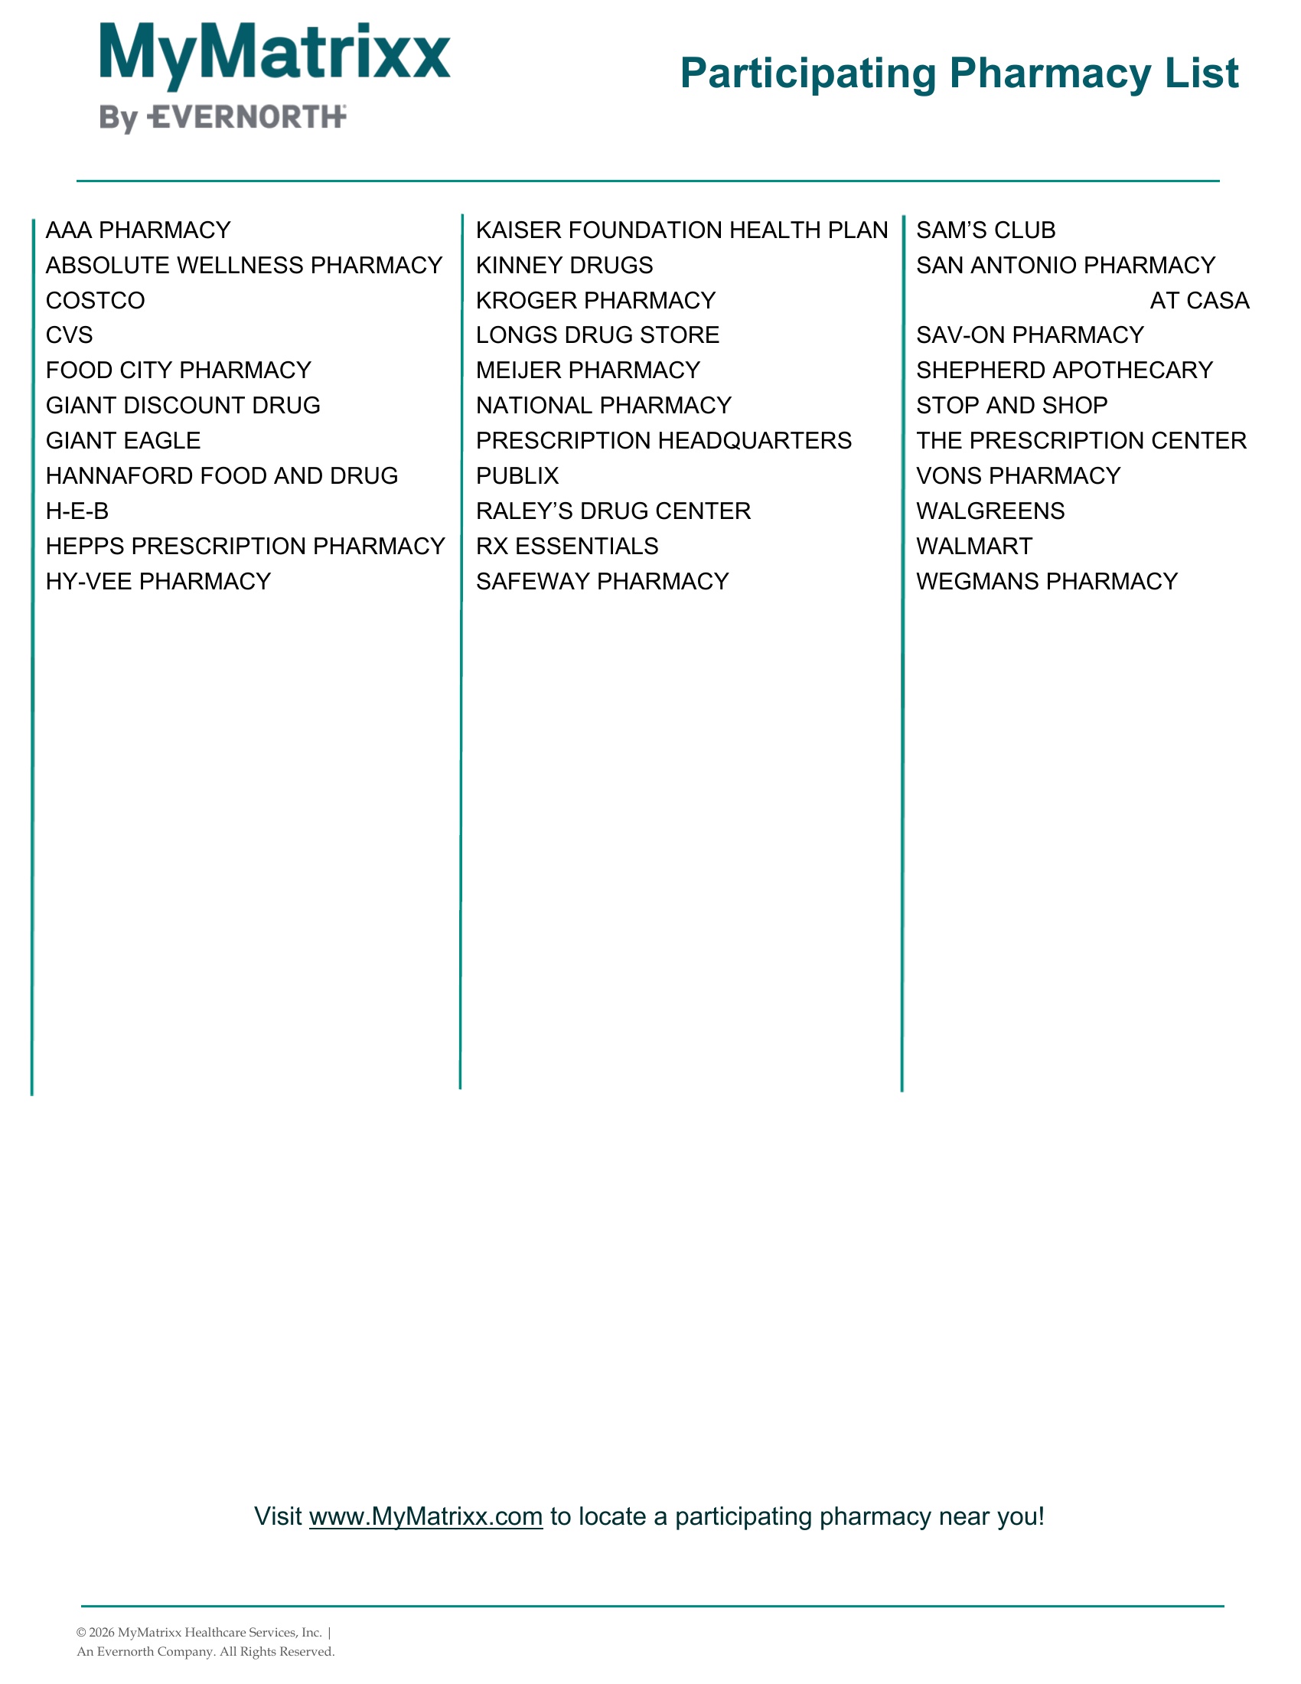

WORKERS’ COMPENSATION DEPARTMENT | EMPLOYEE FORM
Employee Injury Report and Offer of Medical Evaluation
To be completed by the employee. Please describe the facts as accurately as you can, then give this form to your supervisor.

1. About You
Employee name | Job title
Home address | Phone number

2. What Happened
Date and time of incident | Date and time you reported it |  | Supervisor you reported it to
Location of incident | City |  | Building / room
What were you doing when the incident happened?

Describe how it happened.

What part(s) of your body were injured? |  | What symptoms do you have?
Witness name(s) |  | Did this incident cause any property damage?  ☐ Yes ☐ No
If yes, describe the property damage.

3. Medical Evaluation Offer
Your agency has offered you a medical evaluation for this incident.
☐ I accept a medical evaluation. ☐ I decline a medical evaluation at this time.
This decision is about medical care at this time only. It does not mean you weren’t hurt, and it does not give up any of your workers’ compensation rights. You can ask for medical care later.
If your symptoms continue or get worse, or you decide you want medical care, tell your supervisor, Human Resources, or your agency’s workers’ compensation contact as soon as possible.
Employee signature | Printed name | Date

4. For Agency Use Completed by the supervisor or agency representative
Claim form (DWC-1) offered on: ______________________ (date)
☐ Agency referred the employee for an evaluation of their ability to safely perform job duties.
Supervisor or agency representative signature | Title | Date

WORKERS’ COMPENSATION DEPARTMENT | MEMBER GUIDE
Using the Employee Injury Report
Guidance for member agency staff. For internal use only. Please don’t give this guide to the employee.

The Employee Injury Report and Offer of Medical Evaluation records the employee’s own account of what happened and their response to your offer of a medical evaluation. It’s optional. It does not replace the DWC-1 claim form, and an employee who declines care does not give up any workers’ compensation rights.
When Declining May Be Appropriate
Deciding whether an employee should be evaluated is a judgment call. If the injury appears to be first aid only, it may be reasonable for the employee to decline. If it doesn’t appear to be first aid only, or the employee can’t safely do their normal job, we recommend an evaluation even if the employee would prefer not to go. Explain that the referral is about their safety and their ability to do the job, not about a claim.
Our First Aid Only guide explains where the line is. When in doubt, have the employee evaluated and call us.
Keep in Mind
- Offer the DWC-1 claim form and record the date in Section 4 of the form.
- Don’t pressure the employee either way, and don’t suggest that declining affects their rights.
- If the employee changes their mind or their symptoms get worse, act on it right away. Arrange care and follow your normal reporting steps.
- If the employee declines both the DWC-1 and an evaluation, document both and call us. Talk with your legal counsel before taking any employment action.
What to Do With the Completed Form
Keep the completed form in the employee’s file.
Send a copy to ACWA JPIA with your Form 5020 whenever you report a claim to us. That includes when:
- The injury goes beyond first aid.
- The injury is first aid only, but the employee wants to file a claim.
- The injury is first aid only, but your agency would rather have us handle it.
If the employee declines care, or the case stays first aid only and your agency handles it in-house, you don’t need to send the form to us.

Questions? Call Us.
ACWA JPIA Workers’ Compensation Claims | Main phone: (916) 786-5742 or (800) 231‑5742
Email: claimswc@acwajpia.com | Workers’ comp fax: (916) 786-0209 | acwajpia.com/report-a-claim

This guide is a general overview and is not legal advice.

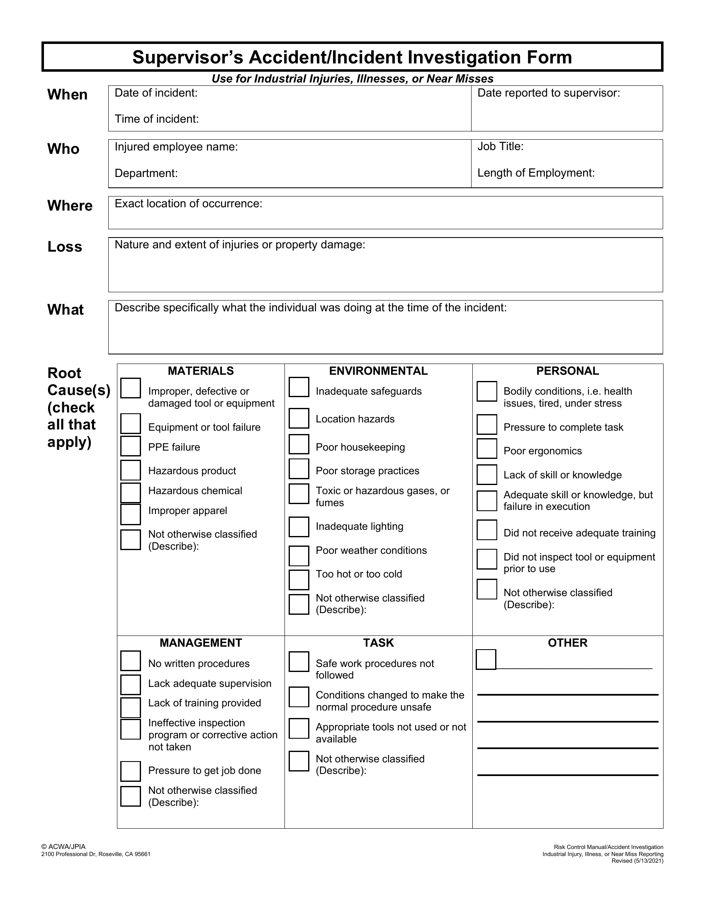

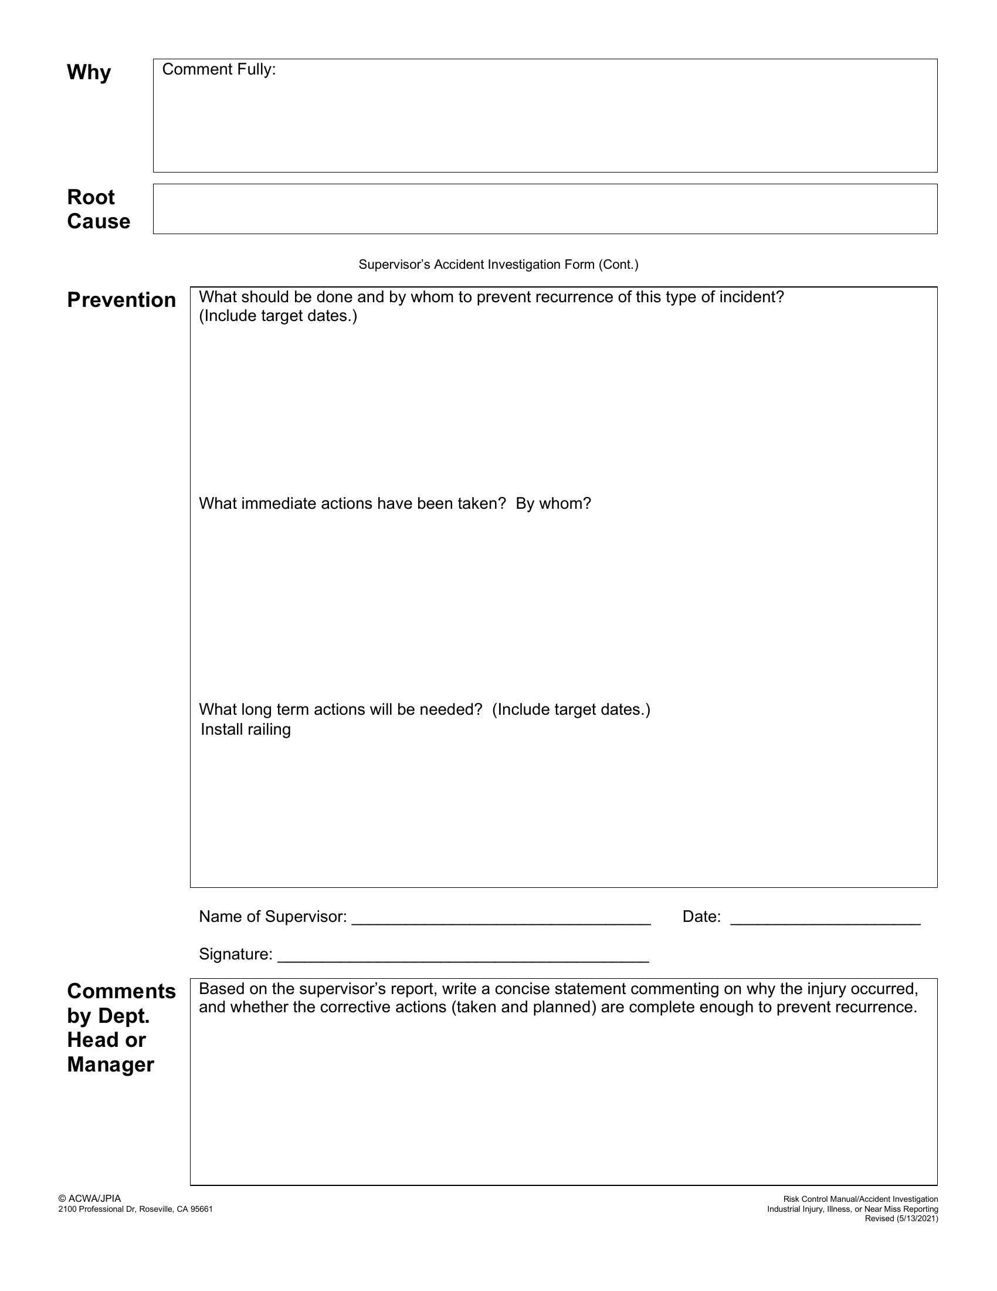

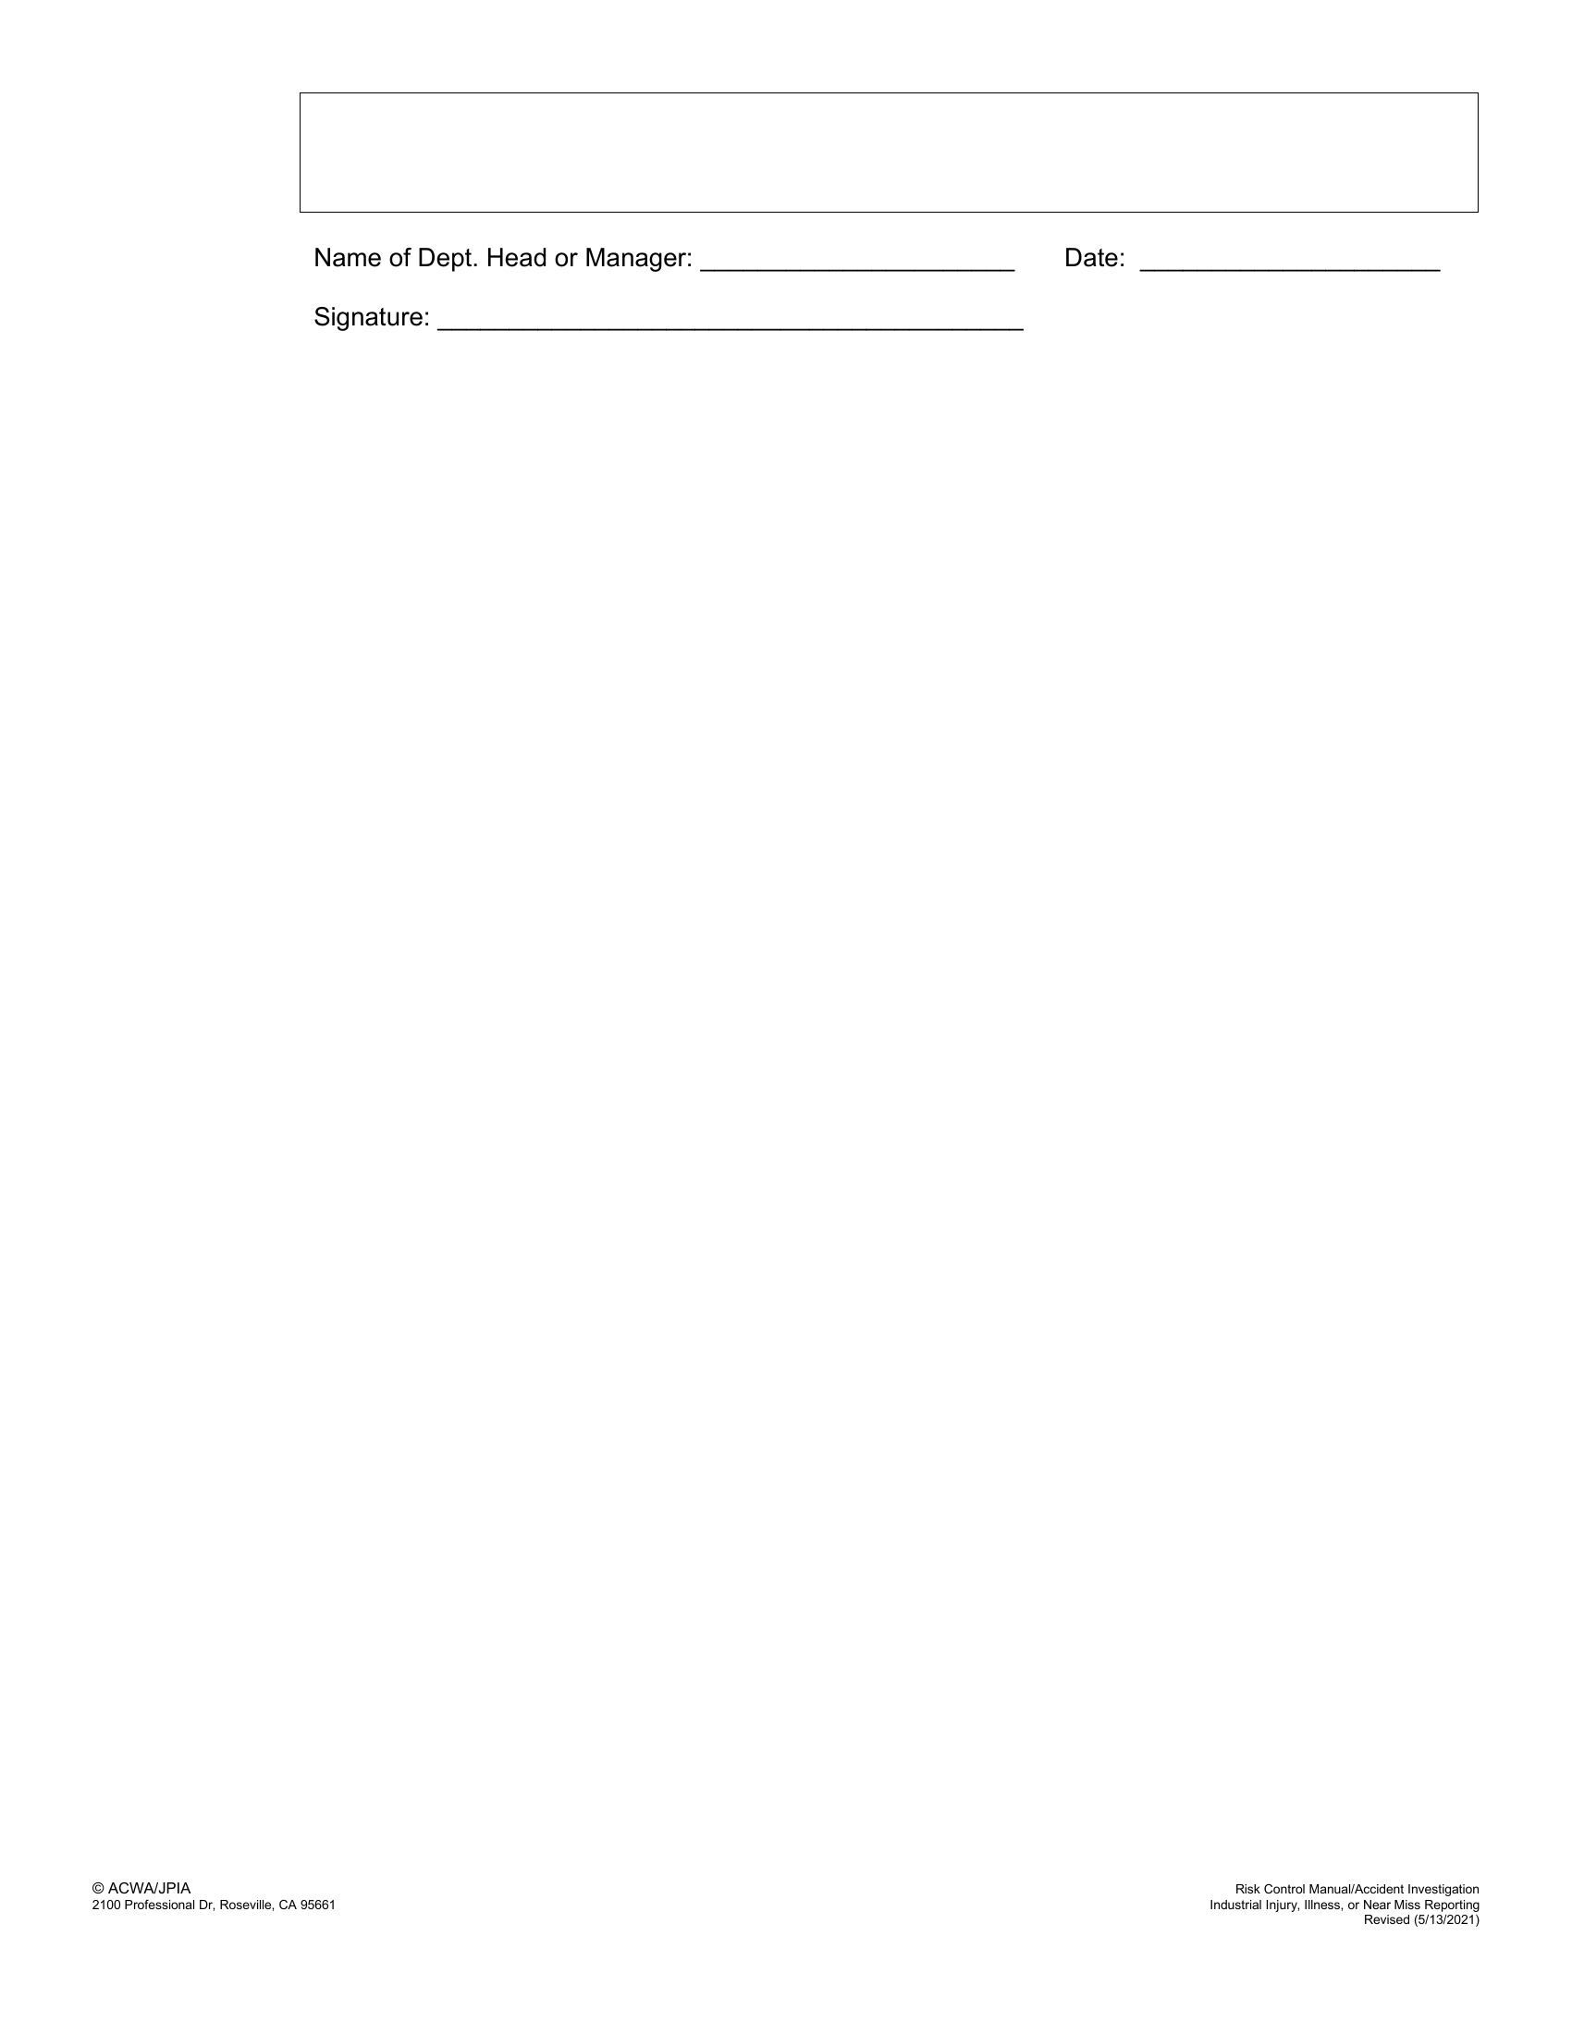

WORKERS’ COMPENSATION DEPARTMENT | MEMBER GUIDE
Your Workers’ Comp Claims Team
Who we are and how to reach us

ACWA JPIA’s own Workers’ Compensation Claims Team handles your claims. There’s no outside carrier or third-party administrator, so you work directly with us.
Reporting a New Injury
Report to the whole team
Online: acwajpia.com/report-a-claim/#workerscomp
Email: claimswc@acwajpia.com (reaches our entire claims team)
Fax: (916) 786-0209 (workers’ comp only)
Questions About an Existing Claim
Once a claim is open, you’ll be assigned an examiner who will stay in touch with you. Contact your examiner directly with questions, new information, or changes in the employee’s work status.
Main Phone
(916) 786-5742 or (800) 231-5742. Use the main line to reach any extension listed below.
Meet the Team
Name and title | Direct line | Main line extension
Erin Bowles  Workers’ Compensation Claims Manager | (916) 232-9242 | ext. 3159
Heather Spain  Lead Senior Workers’ Compensation Examiner | (916) 547-2684 | ext. 3178
Kristin Smith  Workers’ Compensation Claims Examiner II | (916) 469-0006 | ext. 3182
Sara Clonce  Workers’ Compensation Claims Examiner II | (916) 755-5373 | ext. 3195
Camille Heinrichs  Workers’ Compensation Claims Examiner II | (916) 222-4639 | ext. 3202
Jennifer Duchene  Claims Assistant | (916) 472-3626 | ext. 3192

